**Batch: H DA - 3 Roll No.: 16010122096**

**Experiment No. 3**

|  |
| --- |
| **Title: Implement spatial data analysis in QGIS** |

# Course Outcome:

# CO2 Apply the data analytics in the field of geospatial system

# Books/ Journals/ Websites referred:

# QGIS Version 3.38-Vector Data Code File-World.shp

# Resources used:

QGIS

______________________________________________________________________

# Algorithm: Spatial Data Analysis

# Spatial Data type: Vector Data

# Step 1: Load Your Vector Data

# Open QGIS.

# Add your vector layer: Go to Layer > Add Layer > Add Vector Layer... and browse to your shapefile or other vector data.

# 

# Step 2: Open the Attribute Table

# Right-click on the layer in the Layers panel.

# Select Open Attribute Table.

# 

# Step 3: Add a New Field for Calculations

# In the attribute table, click on the Field Calculator icon (it looks like an abacus).

# 

# Step 4: Calculate Area

# In the Field Calculator dialog:

# Check the option Create a new field.

# Enter a name for the new field (e.g., "Area").

# Set the output field type to Decimal number (real).

# In the Expression field, enter the following expression to calculate the area in square meters:

# $area

To get the area in hectares:

$area / 10000

Click OK to create the new field and calculate the areas.

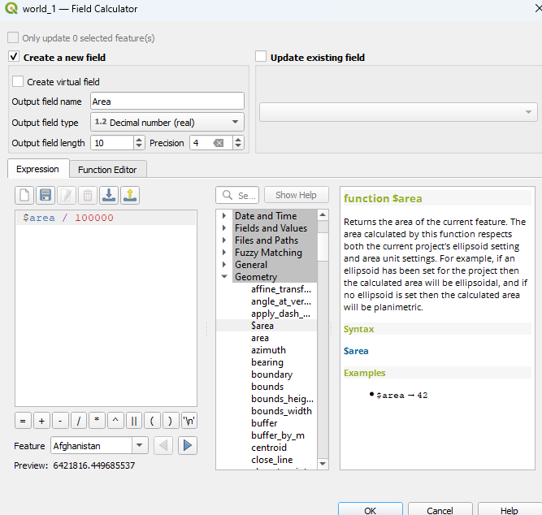

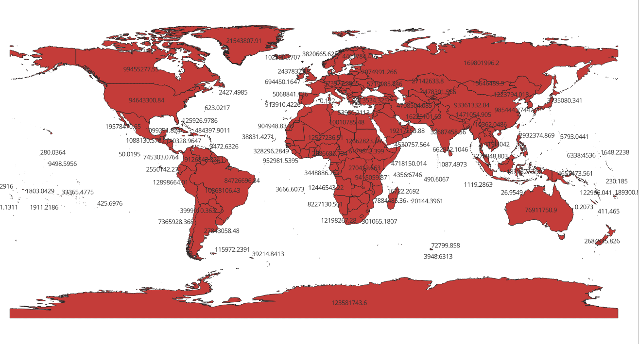Step 5: Calculate Perimeter (for polygons):

perimeter($geometry)

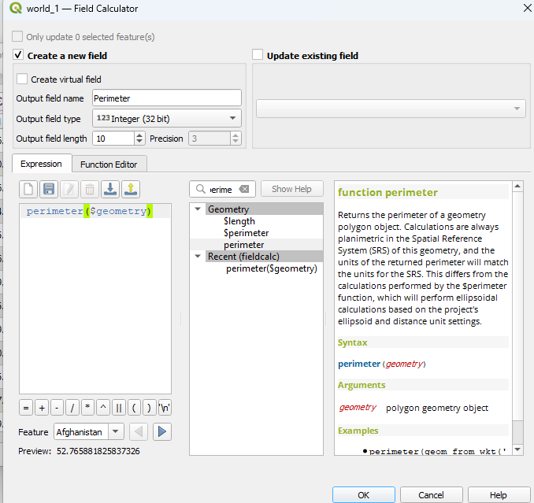

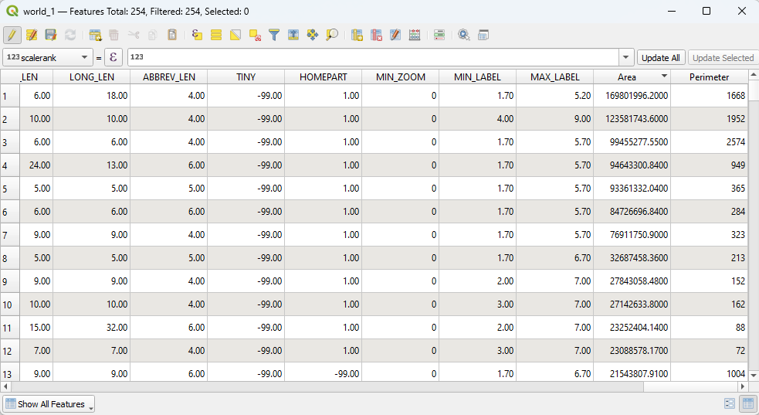

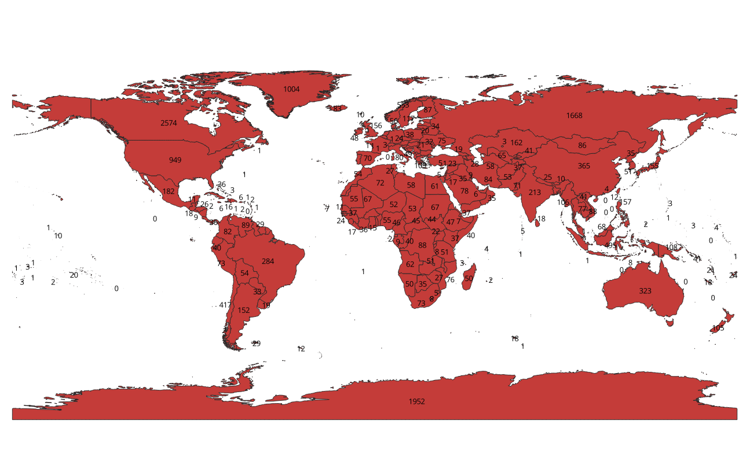

**Task: To work on other geometric properties like centroid using different expressions in the Field Calculator.**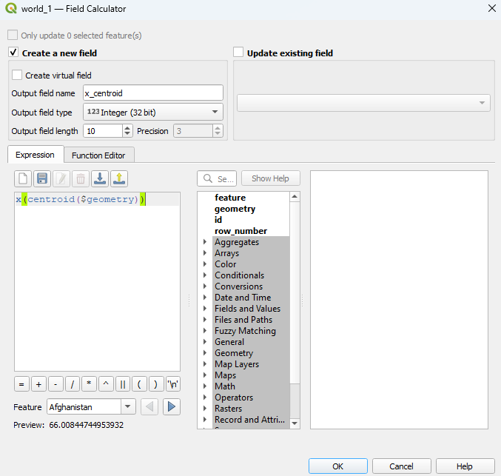 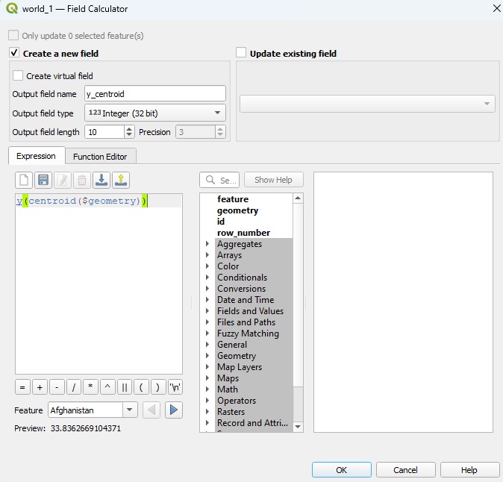

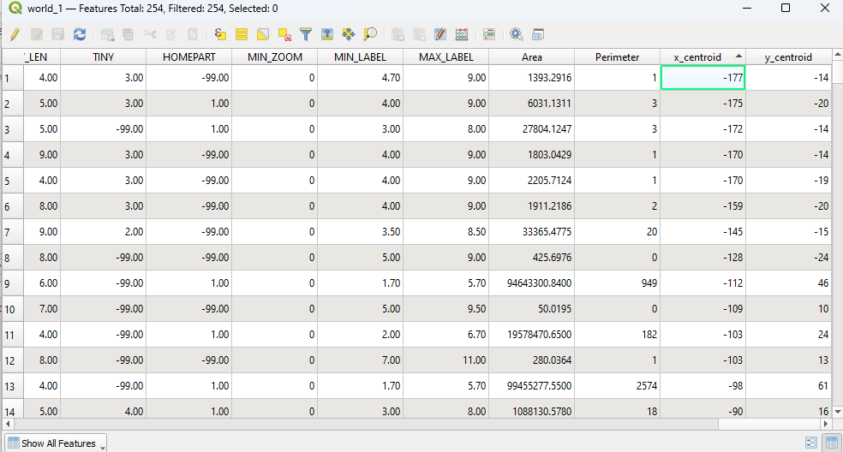 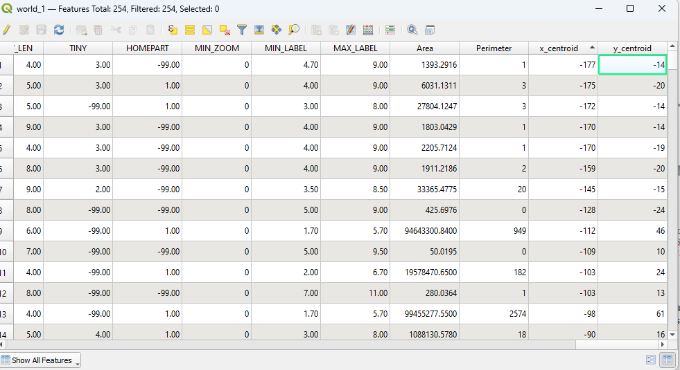

x-centroid: 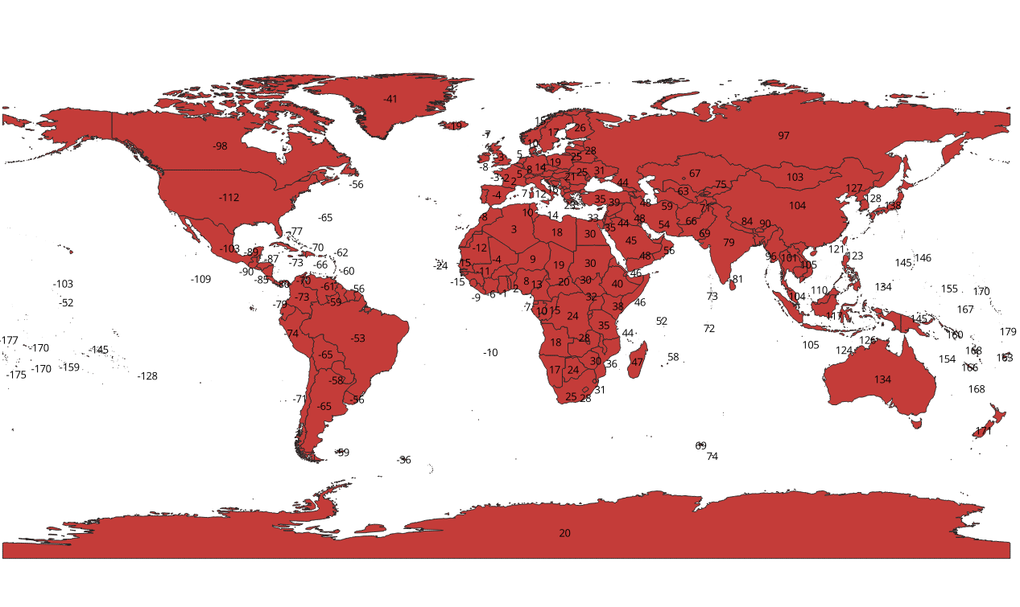 y-centroid: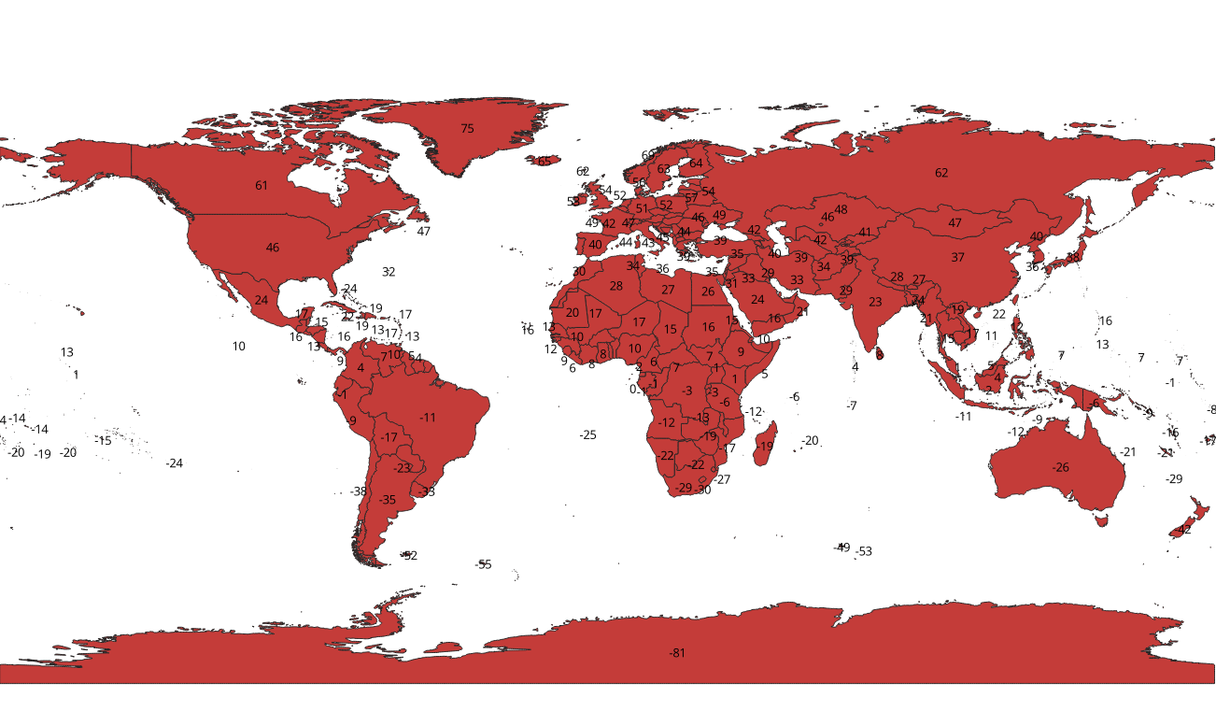

# Filtering by Asia:

# 

# 

# Platform used by the student: QGIS

# Different Geometric Properties used in spatial data analysis.

• **Distance**:

* **Euclidean Distance**: This is fundamental in many spatial analyses, such as determining the proximity between points, calculating travel distances, and assessing spatial relationships.

• **Area**:

* Measuring the area of geographic features is essential for understanding the size and extent of spatial phenomena, whether you're analyzing land use, habitat areas, or property sizes.

• **Perimeter**:

* The perimeter of a feature helps in evaluating the boundary length, which is useful for understanding the shape complexity, assessing accessibility, and in environmental studies.

• **Topology (Adjacency and Contiguity)**:

* Topological relationships like adjacency (features sharing a boundary) and contiguity (features connected through shared boundaries) are critical for understanding spatial relationships and networks, such as road systems or ecosystems.

• **Centroid**:

* The centroid provides the geometric center of a feature and is useful for spatial analysis, including calculating the central point of a region for further analysis or visualizing the average location of features.

# Conclusion (Students should write in their own words):

Implementing spatial data analysis in QGIS enhances geospatial system insights, enabling effective data interpretation and informed decision-making.

**Post lab questions:**

**Q.1 What are different geometric properties used in spatial data analysis on vector data with expression?**

• **Distance**: Calculated using expressions like distance($geometry, geometry(@parent)) to measure the distance between features.

• **Area**: Calculated using area($geometry) to determine the size of polygons.

• **Perimeter**: Calculated using length($geometry) to find the boundary length of polygons.

• **Centroid**: Located with centroid($geometry) to find the geometric center of a polygon.

• **Bounding Box**: Calculated using boundingBox($geometry) to determine the smallest rectangle enclosing the feature.

**Q.2 What are different geometric properties used in spatial data analysis on raster data with expression?**

• **Cell Value**: Accessed with expressions like raster_value(@layer, $x, $y) to retrieve the value of a specific cell.

• **Zonal Statistics**: Calculated with raster_statistics(@layer) to summarize values within defined zones.

• **Distance to Raster**: Measured using raster_distance(@layer, $x, $y) to find distances from cells to certain features.

• **Slope**: Derived from elevation data using expressions like slope(@layer) to analyze terrain steepness.

• **Aspect**: Calculated with aspect(@layer) to determine the direction of slope incline.

**Q.3 What is spatial data analysis and write its advantages.**

**Spatial Data Analysis** involves examining geographic data to uncover patterns, relationships, and trends. It includes techniques like overlay analysis, proximity analysis, and spatial interpolation.

**Advantages:**

1. **Enhanced Decision-Making**: Provides insights for better planning and resource management.
2. **Pattern Recognition**: Identifies spatial patterns and trends.
3. **Problem Solving**: Aids in solving complex spatial problems by analyzing relationships and interactions.
4. **Data Integration**: Combines various data types for comprehensive analysis.
5. **Predictive Analysis**: Supports forecasting and scenario modeling for future planning.Top of FormBottom of Form